# Modern layout

In the old days we were forced to use **tables** to layout sections of the page:

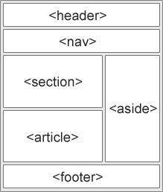

There are many better ways to achieve this now.

* Css float layouts
* Css flexbox layout
* Css grid layout (<https://developer.mozilla.org/en-US/docs/Web/CSS/CSS_Grid_Layout/Realizing_common_layouts_using_CSS_Grid_Layout>)
* Or using a framework (see below)

We will be looking at bootstrap (tailwindcss is another common framework)

Getbootstrap.com

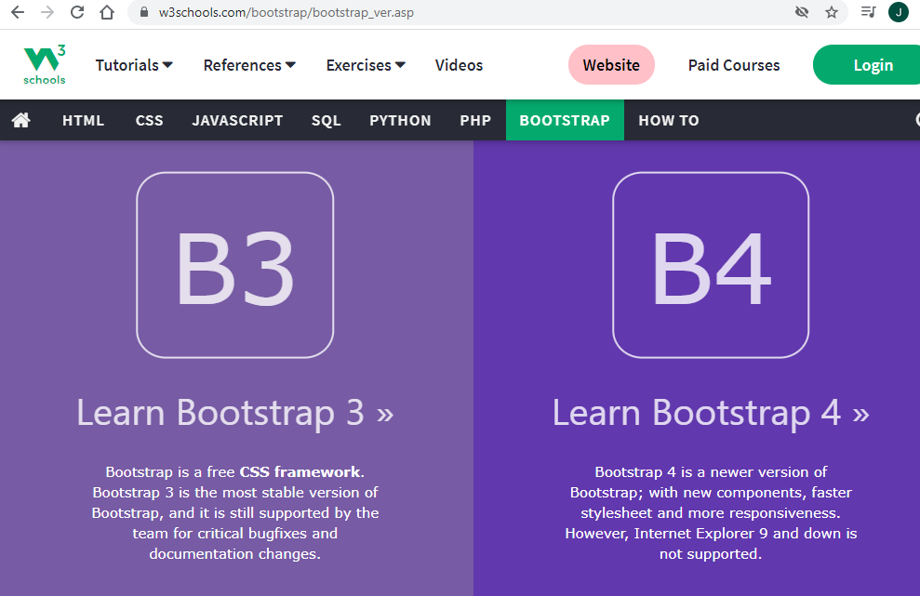

For the tasks below choose a layout and implement it using the css technology listed.

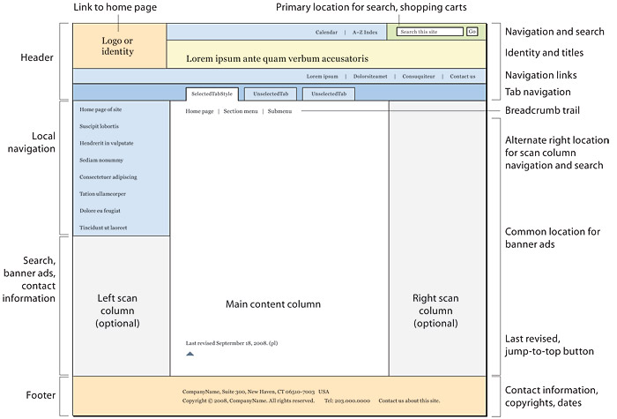

<https://downloadfestival.co.uk/news-features/5-most-moshable-biffy-clyro-tracks/>

<https://cxl.com/blog/first-impressions-matter-the-importance-of-great-visual-design/>

## Task 1

From the template.html create a new web page. Using an external .css file create a beautiful layout using floats.

## Task 2

From the template.html create a new web page. Using an external .css file create a beautiful layout using flexbox.

## Task 3

From the template.html create a new web page. Using an external .css file create a beautiful layout using grid.

## Task 4

From the template.html create a new web page. Using an external .css file create a beautiful layout using bootstrap grid. Make sure that it is responsive